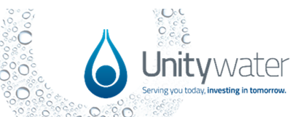
Off Maintenance Certificate
Accreditation and Certification

South-East Queensland Water (Distribution and Retail Restructuring) Act 2009

Approval Details

Connection Approval No: Enter Connection Approval Number]

Development Stage: Enter Development Stage Number ]
Street Address: [Street Address] [Suburb] [STATE] [Postcode]

Property Description: [Lot and Plan Number/s]

Local Government Area: Select Local Government Area.

Date of Acceptance On-Maintenance: Click to Enter Date.

Date of Issue: Click to Enter Date.

Date of Acceptance Off-Maintenance: Click to Enter Date.
Unitywater network works associated with the above development are accepted off-maintenance as at the off-maintenance acceptance date above. The defects liability period (maintenance period) is now complete for the Unitywater network works associated with the above-mentioned Connection Approval.

Please note that authorisation will be given for the maintenance bond held by Unitywater as shown on the following table to be released:

Asset Type | Bond Reference Number | Amount
Water Supply | [Input Number] | $[XXX]
Sewerage | [Input Number] | $[YYY]

Note: Where a bank guarantee is provided by the applicant for bond purposes the release of the bank guarantee document by Unitywater will be directly to the financial institution for the guarantee and NOT to the applicant.

Please allow for up to 20 business days for the release of the above bonds before contacting Unitywater for progress of the bond release.

If you have any queries, please contact Unitywater at Development.Services@unitywater.com or by phone on 1300 086 489.

Yours sincerely

Select Responsible Officer.

Delegated Officers Title

Development Services

